UCD School of Electrical, Electronic



& Communications Engineering

EEEN30110 Signals & Systems

Signed: _________________________________

Date: _________________________________

Lab 2 Signals and Systems Report

*Fergal Lonergan 13456938*

**Declaration: I declare that the work described in this report was done by the person named above, and that the description and comments in this report are my own work, except where otherwise acknowledged. I have read and understand the consequences of plagiarism as discussed in the EECE School Policy on Plagiarism, the UCD Plagiarism Policy and the UCD Briefing Document on Academic Integrity and Plagiarism. I also understand the definition of plagiarism.**

Lab 2 Signals and Systems Report

**Objective:**

To investigate the trigonometric Fourier series.

## Question 1

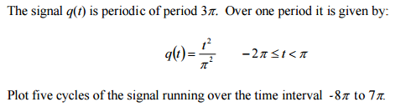

We were given the signal which was periodic of period 3 $π:$

q(t) = $\frac{t^{2}}{π^{2}}$ for - $-2π≤t<π$

I utilized Matlab to plot the function for 5 cycles i.e. from -8 $π to 7π$.  
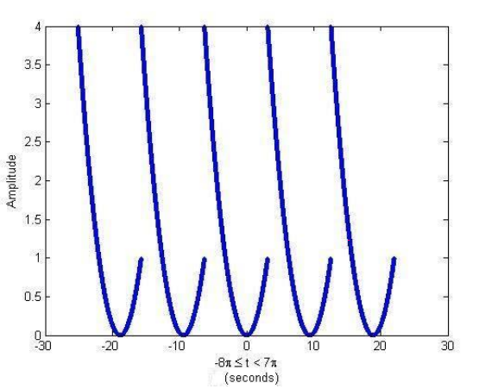

Question 2:



To determine the trigonometric Fourier series of the signal *f*(𝑡) we can use definition 3:1 in the notes which states that any periodic signal *f* of period T the Fourier coefficients of *f* are the associated numbers:

$$c_{n}=\frac{1}{T}\int_{0}^{T}{f\left(t\right)e^{-jnwt}dt}$$

Then subbing in for our period T (3 $π$) and our function *f* (q) to get:

$$c_{n}=\frac{1}{T}\int_{-2π}^{π}{\frac{t^{2}}{π^{2}}e^{-jnwt}dt}$$

Then using integration by parts I ended up with the following function:

$$c_{n}=\left(\frac{1}{3π}\right)\left(\frac{e^{-\frac{2}{3}jnπ}-9j+6nπ+2jπ^{2}n^{2}}{4n^{3}π^{3}}-\frac{e^{\frac{4}{3}jnπ}\left(-9j+2jπn+2jn^{2}{\left(2π\right)}^{2}\right)}{4n^{3}π^{2}} \right)$$

## Question 3:



After finding the formula used above I used Matlab’s fft command and determined that the following first seven Fourier co-efficeints of the formula q(t):

|  |  |
| --- | --- |
| Co-efficient | Value |
| $$C_{0}$$ | 1 |
| $$C_{1}$$ | -0.6415 – 0.1561j |
| $$C_{2}$$ | 0.149 + 0.2181j |
| $$C_{3}$$ | 0.0507 – 0.1592j |
| $$C_{4}$$ | -0.1176 + 0.035j |
| $$C_{5}$$ | 0.0736 + 0.0636j |
| $$C_{6}$$ | 0.0127 – 0.0796j |

## Question 4:



As q(t) is a periodic function we are able to use the following formula to calculate the first thirteen terms of the Fourier series of q(t) is :

$$c_{0}+\sum_{n=1}^{∞}{α_{n}\cos\left(nω_{0}t\right)+β_{n}\sin\left(nω_{0}t\right)}$$

Where:

$$c_{0}=\frac{1}{T}\int_{0}^{T}{q\left(t\right)dt}$$

$$α_{n}=2Re\left(c_{n}\right)=\frac{2}{T}\int_{0}^{T}{q\left(t\right)\cos\left(nω_{0}T\right)dt}$$

$$β_{n}=-2Im\left(c_{n}\right)=\frac{2}{T}\int_{0}^{T}{q\left(t\right)\sin\left(nω_{0}t\right)dt}$$

Then taking the co-efficients I obtained in question 3 I found the following first thirteen terms of the Fourier series:

|  |
| --- |
| 1 |
| -1.283cos($\frac{2}{3}$ t) +0.3122sin( $\frac{2}{3}t)$ |
| 0.2994cos( $\frac{4}{3}t)-0.4362sin⁡(\frac{4}{3}t)$ |
| 0.1014cos(2t)+0.3184sin(2t) |
| -0.2352cos( $\frac{8}{3}t)-0.07sin⁡(\frac{8}{3}t)$ |
| 0.1472cos( $\frac{10}{3}t)-0.1272sin⁡(\frac{10}{3}t)$ |
| 0.0254cos(4t)+0.1593sin(4t) |

## Question 5:

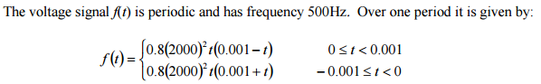  
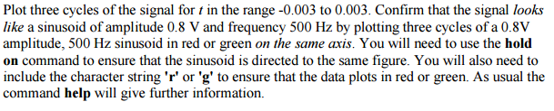

The signal *f*(t) is a voltage signal with a frequency of 500Hz. We are told it is periodic and defined over one period as: $f\left(t\right)=\left\{\begin{aligned}0.8{\left(2000\right)}^{2}t\left(0.001-t\right) \\ 0.8{\left(2000\right)}^{2}t\left(0.001+t\right)\end{aligned}\right.$ ${0 ≤ t < 0.001 \atop -0.001 ≤ t < 0}$

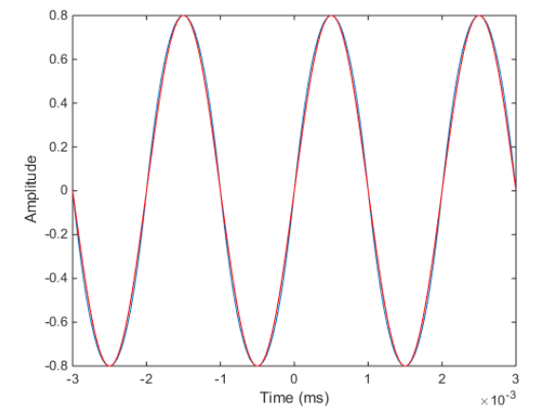

By plotting both *f*(t) in blue and the 0.8V amplitude, 500Hz sinusoid signal in red on the same figure as instructed, it is clear to see that the signals appear to be almost identical.

## Question 6:

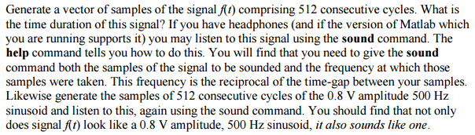

I generated a vector of samples comprising of 512 cycles of the signal *f*(t). I then got the period of this signal and used this to calculate that the signal is 1.024 seconds long as:

$$ω=\frac{1}{T}=\frac{1}{500}=0.002$$

After listening to the sounds I noticed that both sounded the same and concurrently our signal *f*(t) seems to be a 0.8V amplitude, 500Hz signal.

## Question 7:



Using the same process as in Question 3 and utilizing Matlab’s fft function I obtained the following first ten Fourier co-efficients:

|  |  |
| --- | --- |
| $$c_{0}$$ | 0+0j |
| $$c_{1}$$ | $${0-0.4128j}_{}$$ |
| $$c_{2}$$ | 0+0j |
| $$c_{3}$$ | $${0-0.0153j}_{}$$ |
| $$c_{4}$$ | 0+0j |
| $$c_{5}$$ | $${0-0.0033j}_{}$$ |
| $$c_{6}$$ | 0+0j |
| $$c_{7}$$ | $${0-0.0012j}_{}$$ |
| $$c_{8}$$ | 0+0j |
| $$c_{9}$$ | $${0-0.0006j}_{}$$ |

Obviously *f*(t) can’t be a sinusoid as for a sinusoid the only term in the Fourier series which is able to equal the signal *f*(t) itself is Asin $(ωt)$.

## Question 8:



As we can see from the coefficients above in question seven the value for $c_{0}$ is equal to 0. Furthermore it is clear that for each coefficient $a_{n}$ is also equal to 0. This reduces our original equation for our Fourier series from:

$$c_{0}+\sum_{n=1}^{∞}{α_{n}\cos\left(nω_{0}t\right)+β_{n}\sin\left(nω_{0}t\right)}$$

To:

$$\sum_{n=1}^{∞}{β_{n}\sin\left(nω_{0}t\right)}$$

Analysing our coefficients more closely it is clear to see that our second coefficient $c_{1}$ = $0-0.4128j$ is much larger than the others. If we then calculate the magnitude of this trigonometric term we notice that it is 0.8256 which is quite close to the magnitude of our sinusoidal voltage wave (0.8V). We also note that as the signal is the sum of all the sinusoidal terms and as our dominating term is so close to 0.8V it is clear to see why it could be mistaken for our sinusoidal voltage signal of amplitude 0.8V and frequency 500Hz.

## Question 9:

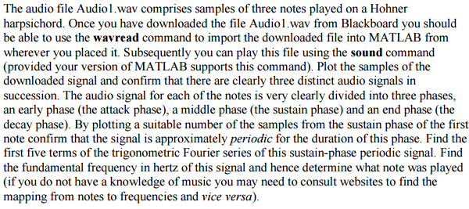

Using Matlab to plot the signal I was able to obtain the following graph:

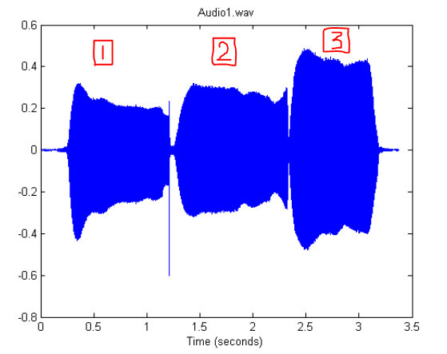

It is clear to see the three distinct audio signals from the graph. I have also denoted them 1, 2 & 3 in red ink with the signals lying below the respective numbers.

If we then plot the graph for the sustain phase of the fist note we see the signal is approximately periodic. An estimation for the period is around 1.9ms judging from the gaps in the peaks. The graph below shows three “periods”. The length of a period if marked below in red.

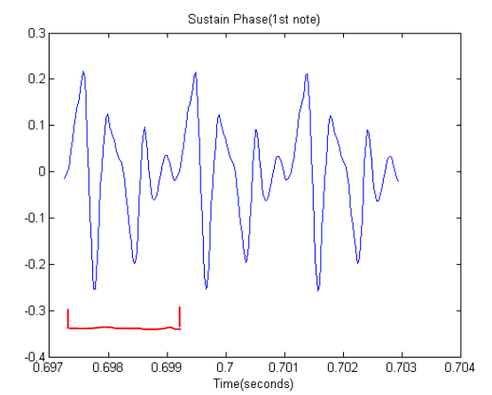

Using the estimate of our period to be 1.9ms we can calculate a value for $ω_{0}:$

$$ω_{0}=\frac{2π}{T}=\frac{2π}{1.9ms}=3307Hz$$

Now using this I calculate the first 5 terms of our Fourier series using the formula:

$$c_{0}+\sum_{n=1}^{∞}{α_{n}\cos\left(nω_{0}t\right)+β_{n}\sin\left(nω_{0}t\right)}$$

And we find:

|  |
| --- |
| 0.0715 |
| -0.0052cos(3307t) – 0.0008sin(3307t) |
| -0.0068cos(6614t)-0.0014sin(6614t) |

So using my value for period time I calculated the frequency of the signal, and then applying the formula:

$$f=\frac{1}{T}$$

We get:

$$f=526.3Hz$$

This corresponds on the frequency table to the musical note $C_{5}$.

Finally listening back to the audio file and comparing to an audio file of the note $C_{5}$ online I can conclude that they are at the very least extremely similar and to my ears the same.